Christian Turner
  Carleton Place, Ontario
  (613) 796-3300
  CTurner@OttawaCloudConsulting.com
  https://linkedin.com/in/Christian-Turner-CloudPro
  https://github.com/OttawaCloudConsulting | 
Senior AWS Cloud Platform Engineer and DevSecOps specialist with 14+ years designing, automating, and securing enterprise-grade cloud platforms. Experienced in building scalable platform engineering capabilities, GitOps automation, and multi-account AWS environments for regulated and private-sector organizations. Expert in Kubernetes/EKS, Crossplane, CI/CD, security-by-design architectures, and cloud governance frameworks.

Skills
- AWS Architecture, Design & Development  - Security by Design  - Automation, CI/CD, and Pipelines | - Scalability, Redundancy & Availability  - DevSecOps and GitOps  - Application Modernization

Technology
- Observability & Operations: Prometheus, CloudWatch, CloudTrail, Operational Dashboards, Incident Response  - Container Platform & Orchestration: ArgoCD, Helm, Kustomize, Cilium, Hubble, External Secrets, Sealed Secrets  - Security & Governance: IAM, IRSA, KMS, CloudTrail, Config, Systems Manager, NIST, CIS, ITSG | - Platform Automation & Provisioning: Crossplane, Terraform, CDK, CloudFormation, KCL  - Cloud Foundation & Compute: EC2, EKS, ECS, Lambda, Fargate, S3, RDS, Aurora, DynamoDB, VPC, Control Tower, ElastiCache  - CI/CD & Release Engineering: Azure DevOps, GitHub Actions, ArgoCD, Release Strategies

Certifications
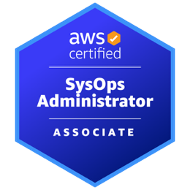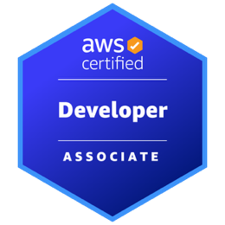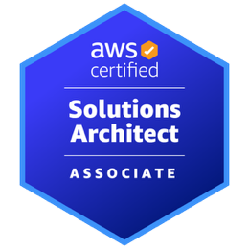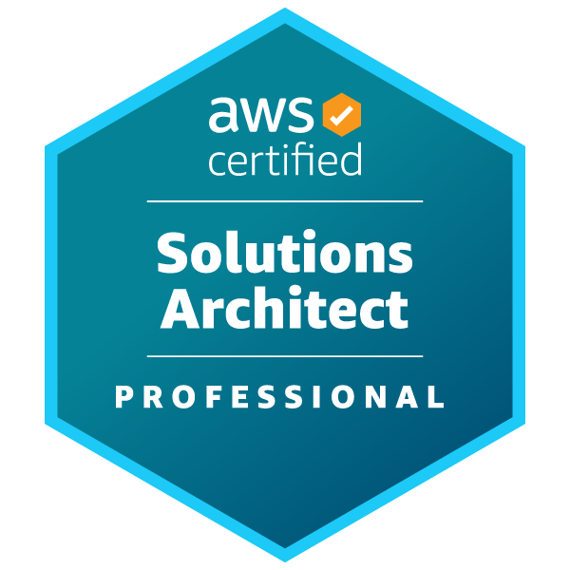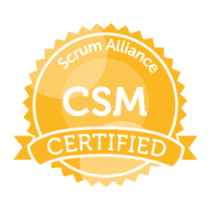
AWS Certified Developer AWS Certified Solutions Architect – Associate
AWS Certified Solutions Architect – Professional AWS Certified SysOps Administrator
Certified Scrum Alliance – Scrum Master

Experience

Platform Engineer/DevSecOps / Ottawa Cloud Consulting / July 2016 - Present
- Architected 3 multi-account AWS organizations managing 200+ workloads with governance, SCPs, identity models, and compliance baselines aligned to NIST, CIS, and ITSG.
- Improved deployment frequency by 30% through GitOps automation with ArgoCD and Azure DevOps, managing over 50 microservices.
- Designed 30+ serverless, event-driven, and containerized workloads reducing operational overhead by 40% and infrastructure costs by $25K annually.
- Engineered 3 production EKS clusters consisting of 3 node groups with auto-scaling node members, implementing IRSA, multi-node isolation, Cilium networking, and hardened RBAC models achieving 99.9% uptime.
- Developed a modular Crossplane + KCL provisioning framework with versioned OCI bundles, provisioning 100+ infrastructure components and reducing deployment errors by 75%.
- Reduced Kubernetes onboarding time by over 60% through deterministic automation and developer Golden Paths.
- Built 12 operational dashboards covering metrics, security, compliance, logs, and incident response signals, improving observability across 3 AWS organizations.
- Authored 25+ design specs, architecture documents, ConOps, runbooks, and security models supporting enterprise deployments across regulated sectors.

DevOps Manager / HighRoads Inc. / June 2015 – December 2016
- Migrated 40+ production workloads from VMware to AWS, reducing costs by 35% and improving platform resilience.
- Delivered active–passive HIPAA-compliant DR architecture meeting strict NIST RTO/RPO objectives.
- Introduced DevOps and automation practices improving deployment frequency by 50% and removing manual steps.
- Operationalized 3 hybrid AWS/on-prem architectures supporting 100+ workloads with scalable and secure patterns.
- Standardized engineering workflows enabling effective collaboration across 15-person off-shore engineering team.

Infrastructure Manager / Dymon Corporation / December 2014 – June 2015
- Migrated 40+ production workloads from VMware to AWS, reducing costs by 35% and improving platform resilience.

IT & DevOps Manager / GeoDigital International / September 2011 – December 2014
- Designed and deployed a GIS SaaS platform on AWS serving 500+ global clients across 15 countries with 99.5% uptime.
- Engineered 1–2 TB/day data ingestion pipeline improving engineering timelines by 50%.
- Delivered secure, robust data-transfer processing 1-2 TB daily for GIS engineering workloads with 99.8% reliability.
- Managed and optimized on-premises PostgreSQL/PostGIS databases supporting high-volume GIS engineering workloads.
- Managed infrastructure operations for 8 production and engineering environments supporting 25+ engineering staff.

